DATA STRUCTURE AND SUMMARY STATISTICS

str(fifa_data)

'data.frame': 4705 obs. of 30 variables:

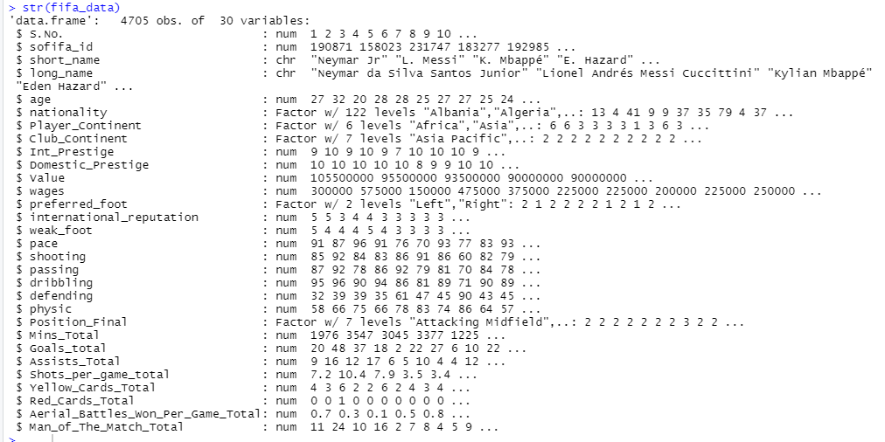

The data has 4075 observations across 30 variables. Of these , the variables S.no , sofifa_id, short_name , long_name are identifiers and will not be used in the analysis for modelling . From the remaining 26 variables 21 variables are numeric and 5 variables are categorical.

> sum(is.na(fifa_data)) ## no nulls in data

[1] 0

We can see that there are no nulls in the data. Hence the data is clean for further exploratory analysis.

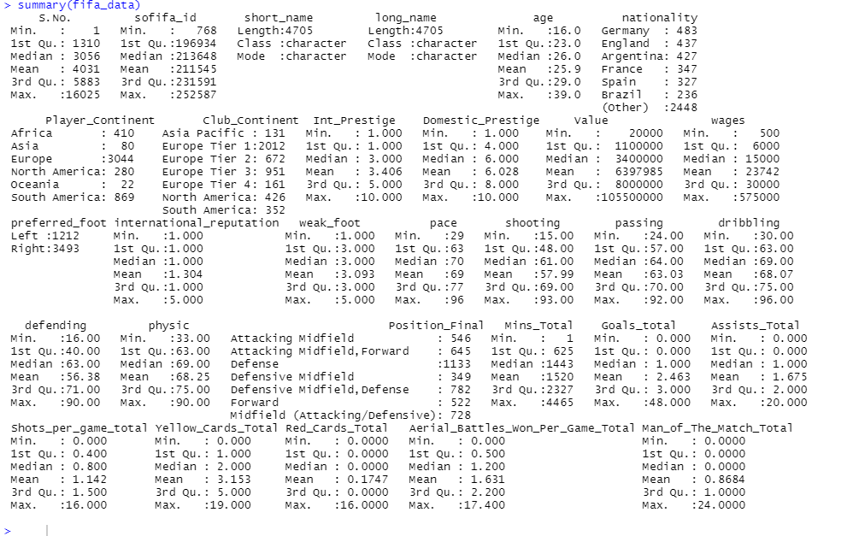

The information above gives summary statistics for each variable. For numerical variables it gives the mean , median , mode , 1st quartile 3rd quartile , maximum and minimum values.

For factors it gives the count of observations against each factor. Interpretation of stats related to character variables is not required.

While important insights can be gained from this information , a better way would be to represent the same information graphically with the help of histograms , boxplots , bar charts , scatter plots etc.

UNIVARIATE ANALYSIS – NUMERIC VARIABLES

Histograms and Boxplots of IVs

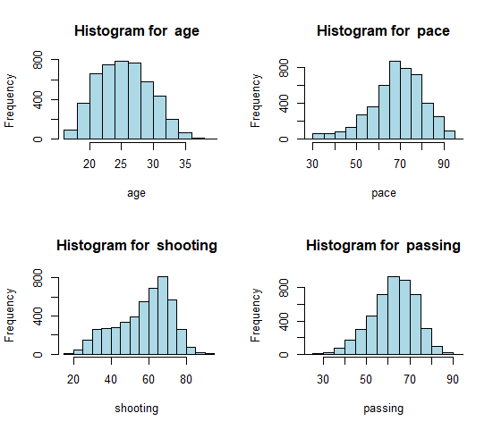 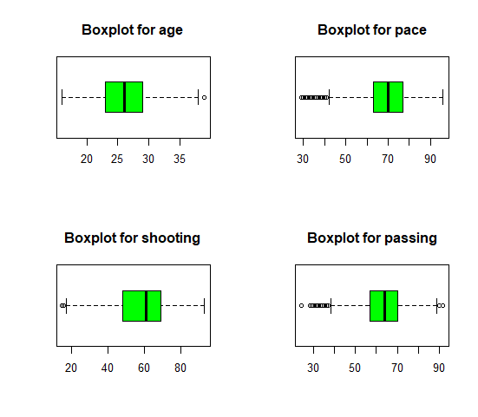

1. Age is more or less normally distributed with a slight right-skew. There aren’t too many outliers in age but the same may be treated for better accuracy in the model
2. Pace , passing and shooting are all approximately normally distributed . All of these have outliers that will need to be treated , particularly pace and passing

 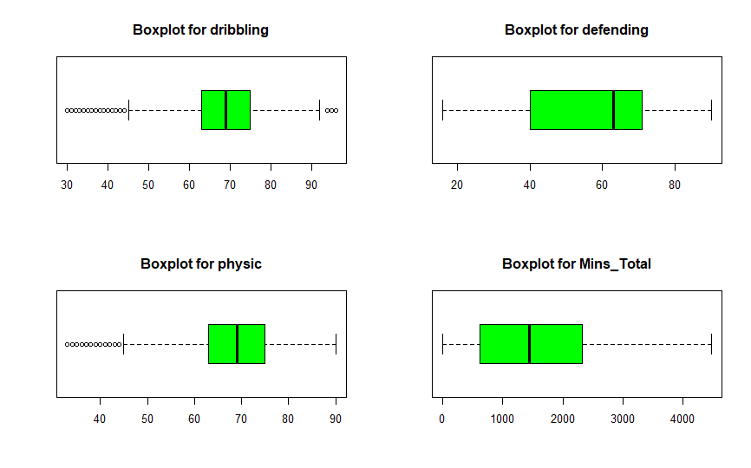

1. In the histograms above , dribbling and physic are the two variables that are slightly right skew. Both have significant number of outliers that may need to be treated.
2. The plots below show highly skewed data with large number of outliers in each case. However, barring yellow cards, the attributes are extremely important in considering a players worth. Hence outliers may be treated only in the case of yellow_cards

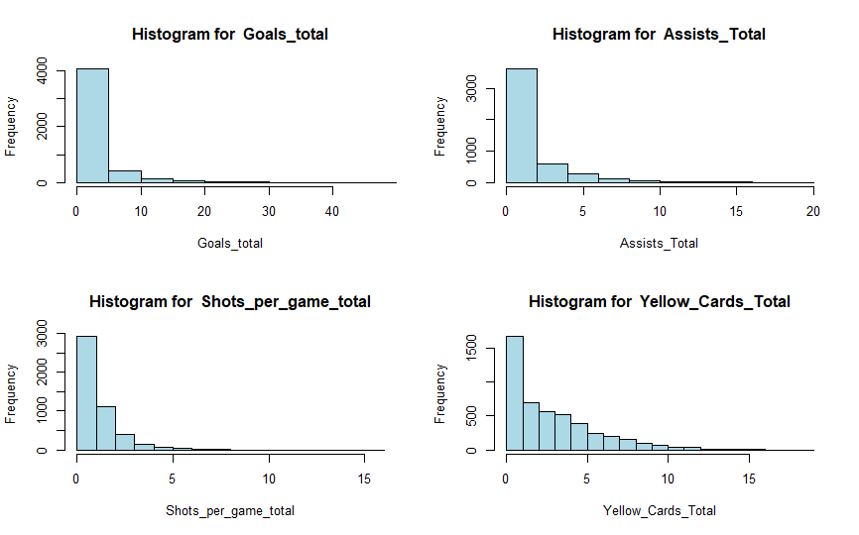 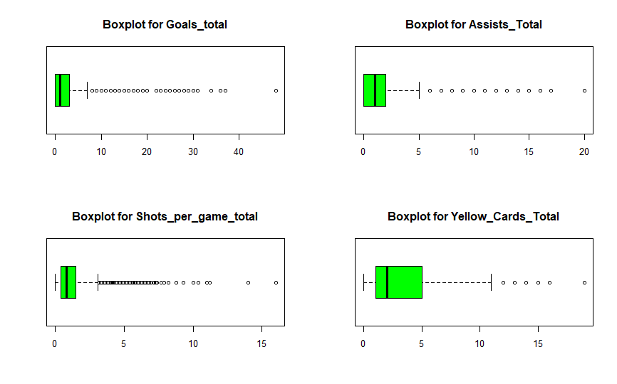

1. Again, the plots below are extremely right skewed. We see can that most of the players did not receive red cards throughout the season. Receiving red cards seems as a highly unlikely event and therefore , the variable may be dropped initially in the analysis. The same holds for the variable man_of_the_match.

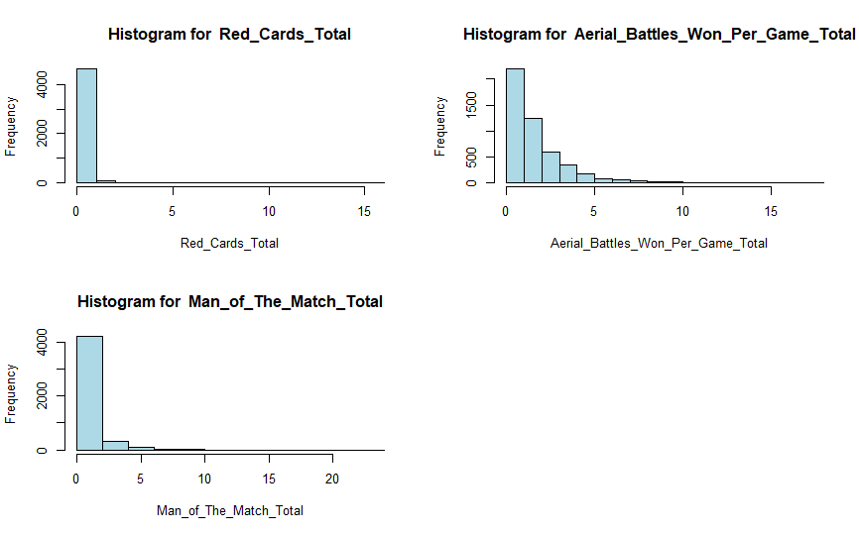 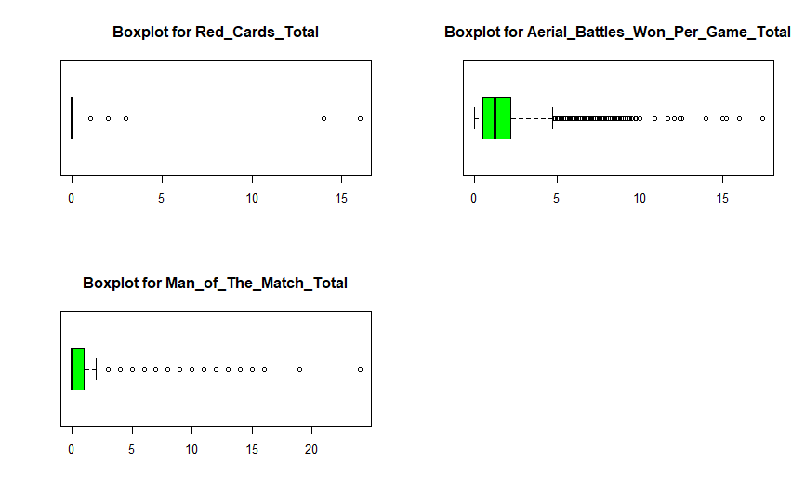

HISTOGRAMS OF DVs

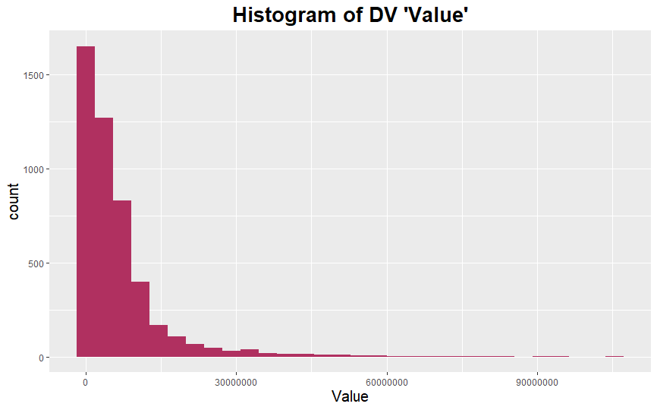 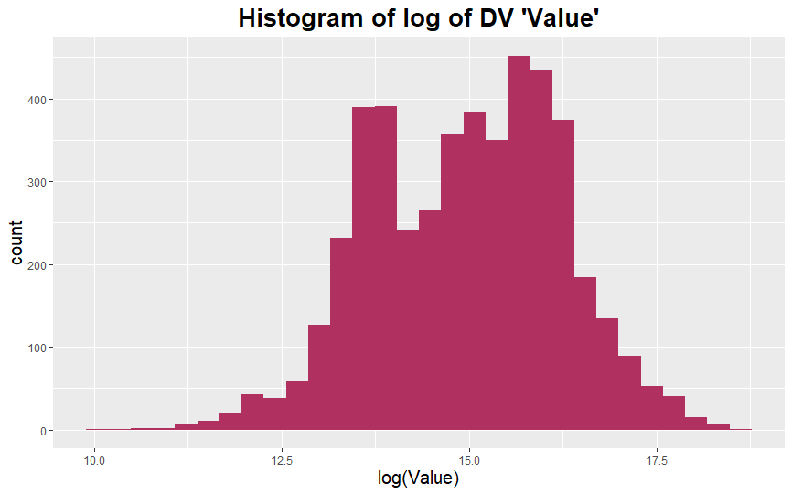

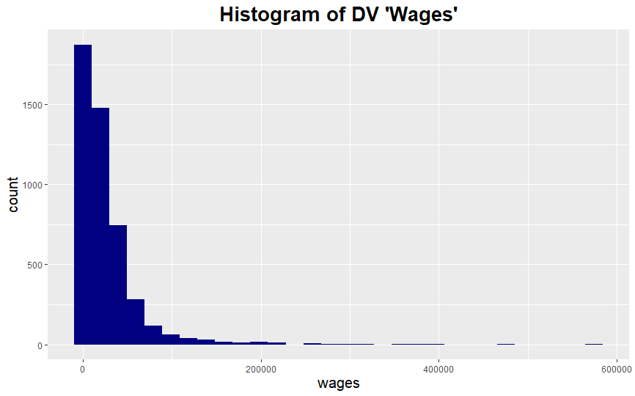 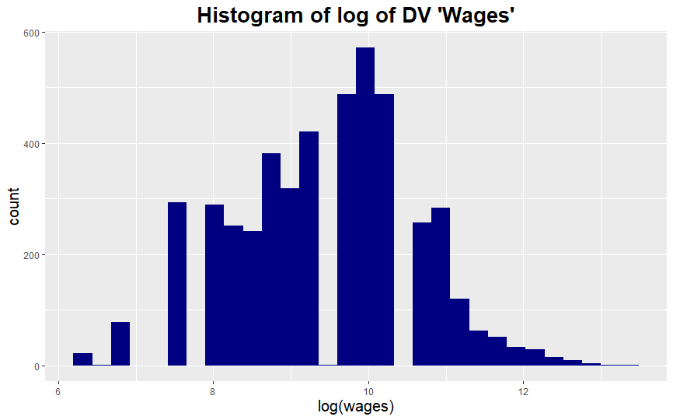

> shapiro.test(fifa_data$Value)

Shapiro-Wilk normality test

data: fifa_data$Value

W = 0.61696, p-value < 0.00000000000000022 -> not normaly distributed

> shapiro.test(log(fifa_data$Value))

Shapiro-Wilk normality test

data: log(fifa_data$Value)

W = 0.99194, p-value = 0.000000000000001049 -> not normaly distributed

> shapiro.test(fifa_data$wages)

Shapiro-Wilk normality test

data: fifa_data$wages

W = 0.55788, p-value < 0.00000000000000022 -> not normaly distributed

> shapiro.test(log(fifa_data$wages))

Shapiro-Wilk normality test

data: log(fifa_data$wages)

W = 0.99114, p-value < 0.00000000000000022 -> not normaly distributed

* We can see that the dependent variables – wages and value – are skewed to the right. Taking a logarithmic transformation gives a distribution that better represents a normal distribution. However the shapiro test which tests the normality of the data shows that neither the original nor the logarithmic versions of the DVs are normally distributed

UNIVARIATE ANALYSIS – CATEGORICAL VARIABLES

BARPLOTS

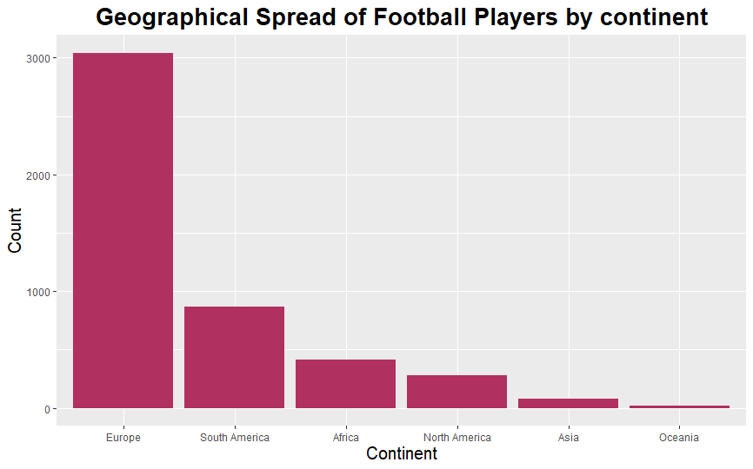 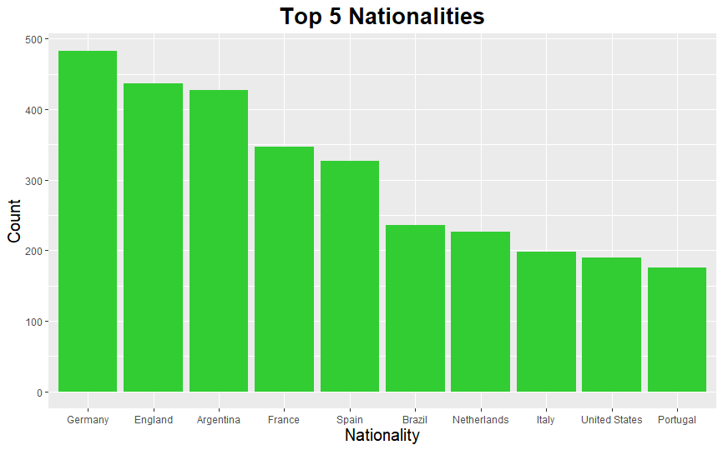

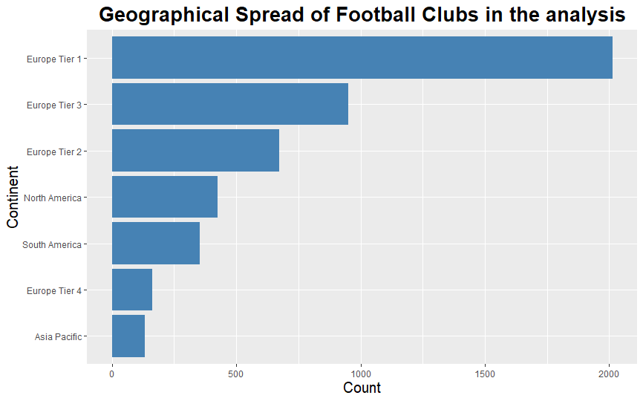 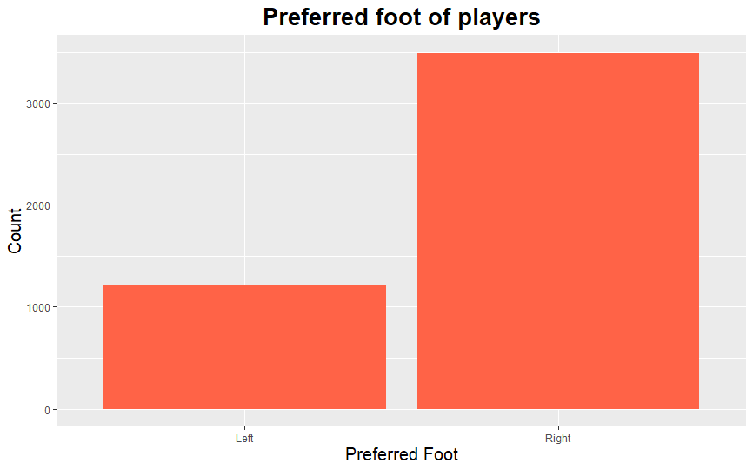

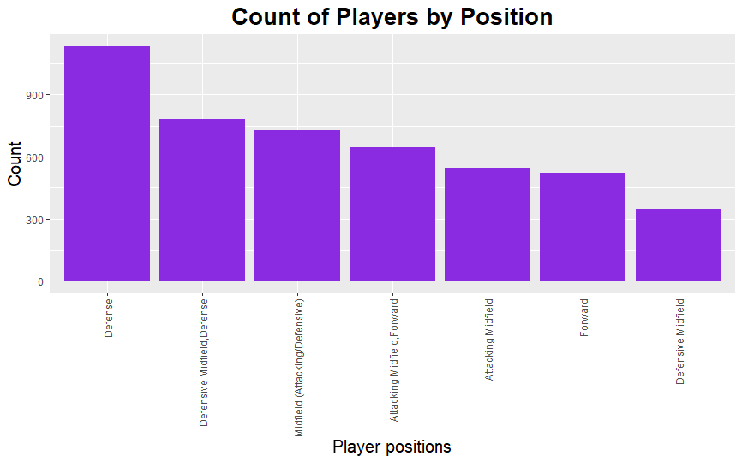 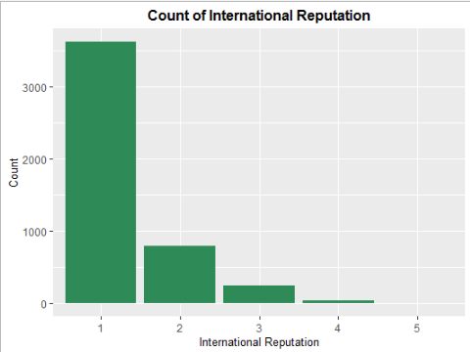

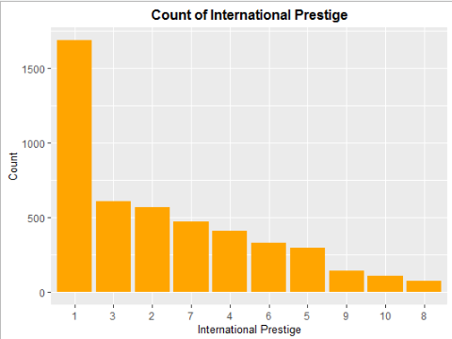 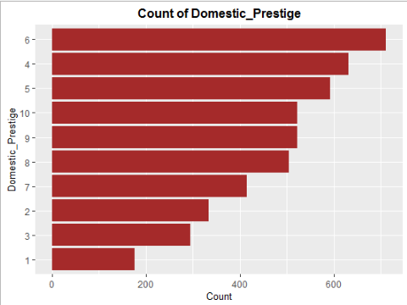

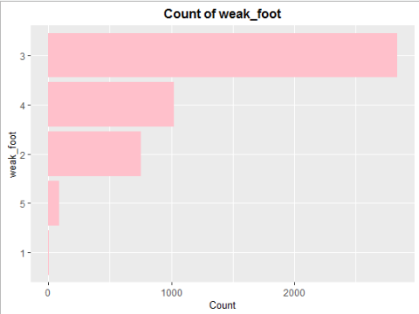

The bar plots above give the following information –

1. Most of the football players in the analysis (approx. 64%) are European. This is expected , since football is the most popular sport in Europe
2. From within Europe , most players are German , making up close to 11% of the total players in the analysis. We can see that 3 non-European countries feature in the top 10 nationalities in terms of number of players. These are Argentina , Brazil and the USA in decreasing order
3. Most of the football clubs in the analysis are also European , as expected
4. Coming to player attributes , majority of the players (approximately 75%) are right footed. Further majority of the players (approximately 25%) in the analysis play in a defensive role i.e. either defense or defensive midfield or both.
5. International prestige is the prestige of the football club internationally .Most of the players belong to the clubs with an International Prestige of 1 which means majority of the players belong to clubs with a low prestige internationally. This is the case because there are only a few clubs which are consistently able to perform at a high level internationally.
6. Domestic Prestige is the prestige of the football club within the league that it belongs to. Most players belong to the clubs which have a local prestige that is neither too good nor too bad.
7. International reputation is the reputation of the player internationally. Majority of the players have an international reputation of 1. Again, this implies that most of the players in the analysis have relatively low repute across the globe. There are only a few players which are reputed highly, and who tend to earn higher wages and sell for higher values
8. Majority of the players have a skill level 3 when it comes to playing with their weak foot.

BIVARIATE ANALYSIS – NUMERIC VARIABLES

CORRELATION MATRIX



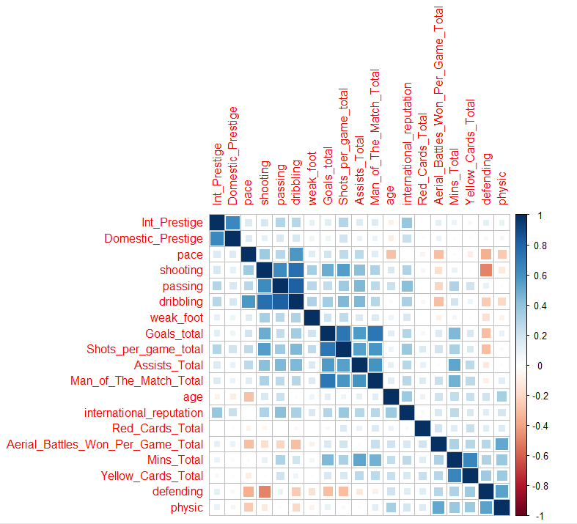

The correlation matrix shows the high correlation ( more than 0.7) between the following variables –

1. Dribbling and shooting – 0.753
2. Dribbling and passing – 0.817
3. Goals and shots per game – 0.724
4. Goal and Man of the match – 0.720

These correlations can suggest the presence of multicollinearity in the model.

**VIF CALCULATION**

To perform further analysis to check if multicollinearity exists, we can calculate the variance inflation factor. To do so , we create a linear regression model , regressing the dependent variable with all the numeric independent variables and then calculate the VIF for each independent variable

Since there are 2 dependent variables in the model , the regression is run twice, once with Value as the dependent variable and once with Wages as the dependent variable.

Generally, a VIF value higher than 5 for a variable indicates the presence of multicollinearity in the model , arising due to the inclusion of that variable.

The table below captures the results –

|  |  |  |
| --- | --- | --- |
|  | **VIF_Value** | **VIF_Wages** |
| **age** | 1.599640671 | 1.599640671 |
| **Int_Prestige** | 2.146959296 | 2.146959296 |
| **Domestic_Prestige** | 1.739648015 | 1.739648015 |
| **international_reputation** | 1.7008643 | 1.7008643 |
| **weak_foot** | 1.154303816 | 1.154303816 |
| **pace** | 2.095978844 | 2.095978844 |
| **shooting** | 4.986175984 | 4.986175984 |
| **passing** | 6.153357855 | 6.153357855 |
| **dribbling** | 7.339317824 | 7.339317824 |
| **defending** | 4.256639599 | 4.256639599 |
| **physic** | 2.188005555 | 2.188005555 |
| **Mins_Total** | 3.071260833 | 3.071260833 |
| **Goals_total** | 3.764713656 | 3.764713656 |
| **Assists_Total** | 2.284715864 | 2.284715864 |
| **Shots_per_game_total** | 3.099372026 | 3.099372026 |
| **Yellow_Cards_Total** | 1.969204156 | 1.969204156 |
| **Red_Cards_Total** | 1.14289031 | 1.14289031 |
| **Aerial_Battles_Won_Per_Game_Total** | 1.93951286 | 1.93951286 |
| **Man_of_The_Match_Total** | 2.57581149 | 2.57581149 |

We can see that dribbling , passing and shooting are the 3 variables with a VIF value higher than 5 ( shooting has a VIF very close to 5) .Therefore, both the correlation matrix and VIF values suggest the presence of multicollinearity in the model. Dribbling is the common variable between both the methods. Hence the variable may be dropped. An alternative approach may be to collapse the multiple predictors causing multicollinearity into fewer dimensions that captures their combined effect , using a dimension reduction technique such as Factor Analysis or Principal Component Analysis. We can then feed the reduced number of dimensions into the analysis for model building





The correlation matrix shows the high correlation ( more than 0.7) between the following variables –

1. Dribbling and shooting – 0.753
2. Dribbling and passing – 0.817
3. Goals and shots per game – 0.724
4. Goal and Man of the match – 0.720

**VIF CALCULATION**

To perform further analysis to check if multicollinearity exists, we can calculate the variance inflation factor. To do so , we create a linear regression model , regressing the dependent variable with all the numeric independent variables and then calculate the VIF for each independent variable

Since there are 2 dependent variables in the model , the regression is run twice, once with Value as the dependent variable and once with Wages as the dependent variable.

Generally, a VIF value higher than 5 for a variable indicates the presence of multicollinearity in the model , arising due to the inclusion of that variable.

The table below captures the results –

|  |  |  |
| --- | --- | --- |
|  | **VIF_Value** | **VIF_Wages** |
| **age** | 1.403886183 | 1.403886183 |
| **pace** | 2.077324585 | 2.077324585 |
| **shooting** | 4.956674053 | 4.956674053 |
| **passing** | 6.111059149 | 6.111059149 |
| **dribbling** | 7.182831036 | 7.182831036 |
| **defending** | 4.086310672 | 4.086310672 |
| **physic** | 2.182733051 | 2.182733051 |
| **Mins_Total** | 3.037890677 | 3.037890677 |
| **Goals_total** | 3.755903018 | 3.755903018 |
| **Assists_Total** | 2.277661121 | 2.277661121 |
| **Shots_per_game_total** | 2.889202199 | 2.889202199 |
| **Yellow_Cards_Total** | 1.958765163 | 1.958765163 |
| **Red_Cards_Total** | 1.132587828 | 1.132587828 |
| **Aerial_Battles_Won_Per_Game_Total** | 1.887723805 | 1.887723805 |
| **Man_of_The_Match_Total** | 2.573597787 | 2.573597787 |

We can see that dribbling , passing and shooting are the 3 variables with a VIF value higher than 5. ( shooting has a VIF very close to 5) Therefore, both the correlation matrix and VIF values suggest the presence of multicollinearity in the model. Dribbling is the common variable between both the methods. Hence the variable may be dropped. An alternative approach may be to collapse the multiple predictors causing multicollinearity into fewer dimensions that captures their combined effect , using a dimension reduction technique such as Factor Analysis or Principal Component Analysis. We can then feed the reduced number of dimensions into the analysis for model building

BIVARIATE ANALYSIS – CATEGORICAL VARIABLES

STACKED BAR PLOTS AND CROSSTABS

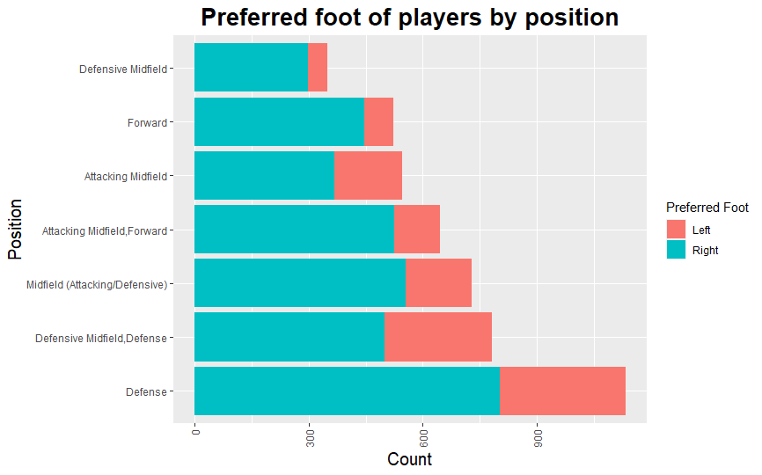 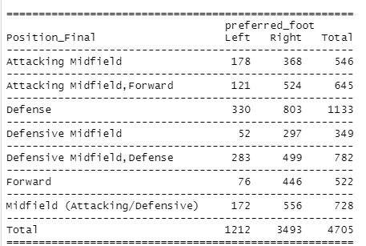

* The above stacked bar chart plots the preference of foot amongst the different positions at which the players in the analysis play. While overall the right foot is preferred , the aim was to check if at any particular position , there is a preference for the left foot. However that does not seem to the case , with the right foot being the predominant foot in every position.

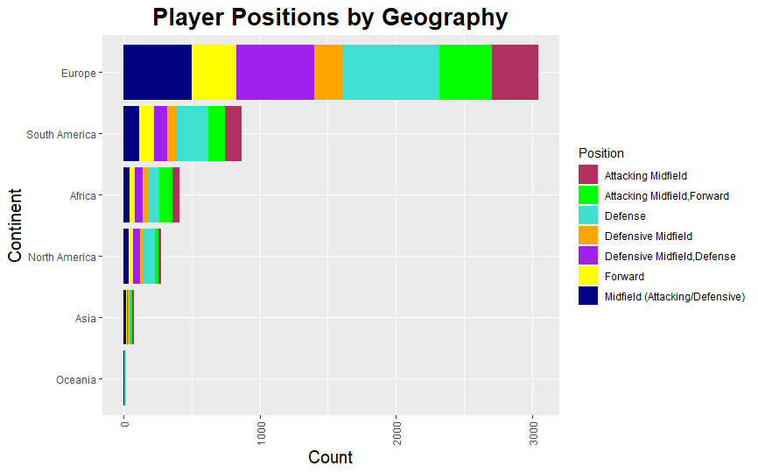

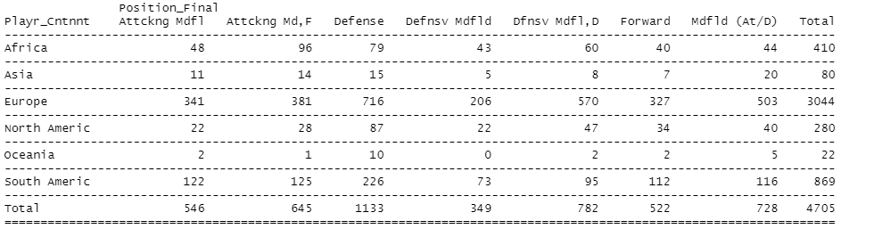

* The plots above aim to show the distribution of player positions across different geographies. While in most continents , defensive players predominate the attacking players, Africa is the only geography where that trend is reversed with more players taking an attacking role rather than a defensive one

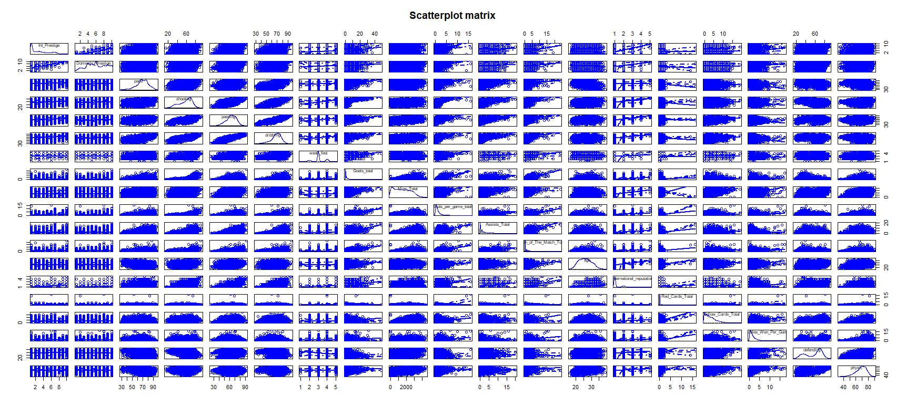

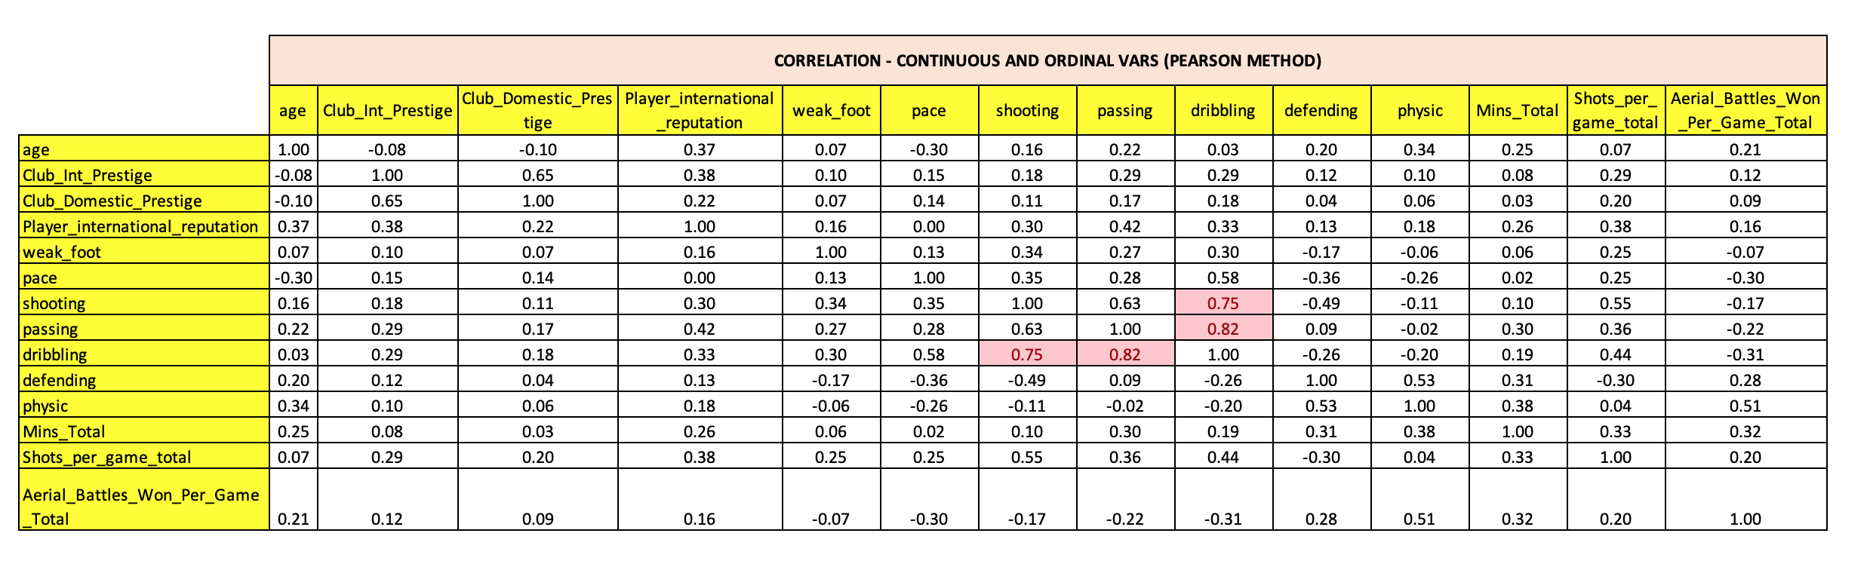

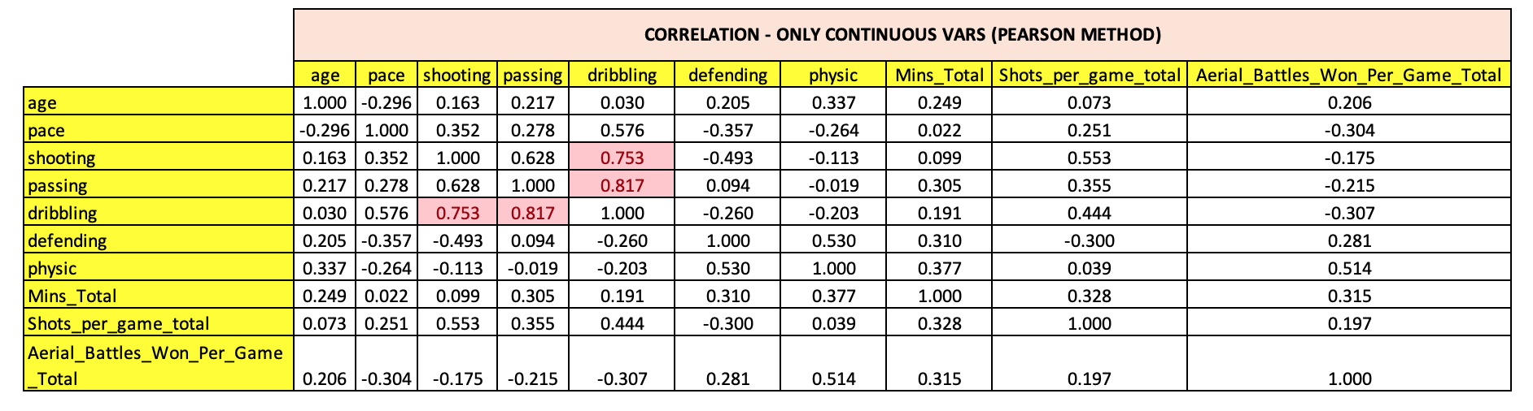

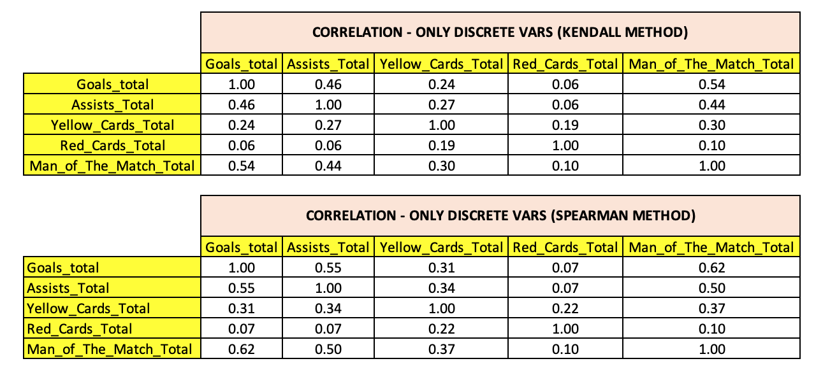

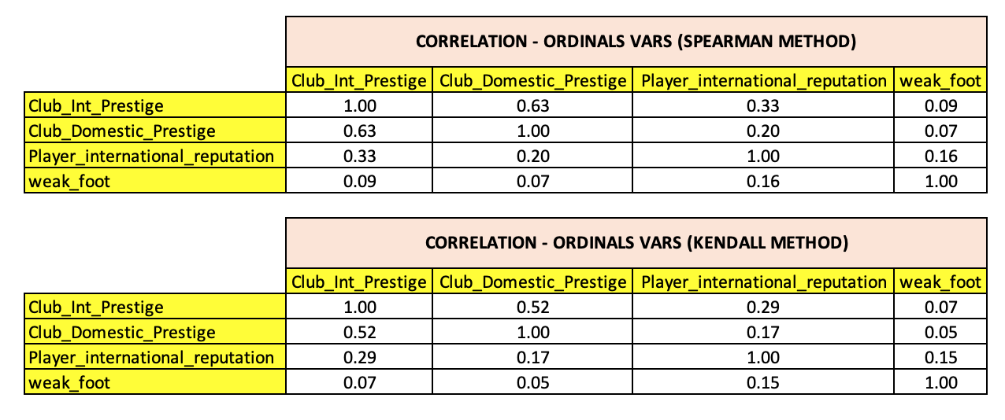

ADDITIONAL EDA

